

BS CYBER SECURITY PROGRAM, DEPARTMENT OF COMPUTER SCIENCE. HITEC UNIVERSITY TAXILLA.

***NAME : SYED ALI AHMED HASHMI***

***REG NO : 24-CyS-058***

***DEPARTMENT : CYBER SECURITY***

***SEC : A***

***COURSE : ARTIFICIAL INTELLIGENCE LAB***

***SUBMITTED TO : SIR MUBASHIR IQBAL***

***LAB REPORT : 04***

TASK : Employee Management:

* Create a Person class with attributes/variables “name” and “age”.
* Create a Job class with attributes/variables “designation” and “salary”.
* Create an Employee class that inherent the above botha classes
* Implement a method to display employee details.

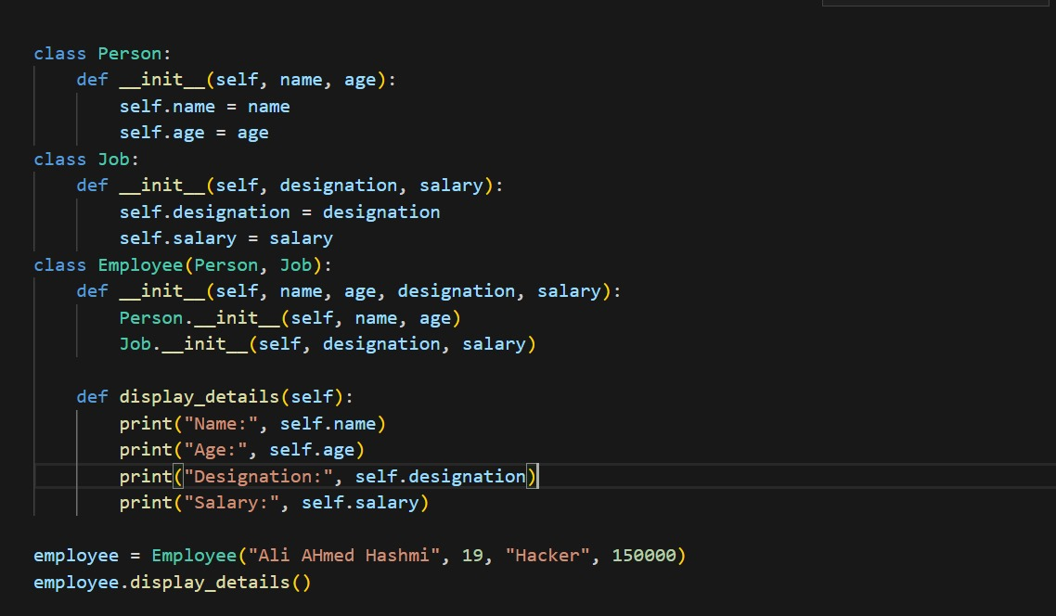

**Output:**

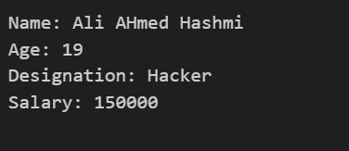

Q : 1 Write a Python class named Circle constructed by a radius and two methods which will compute the area and the perimeter of a circle.

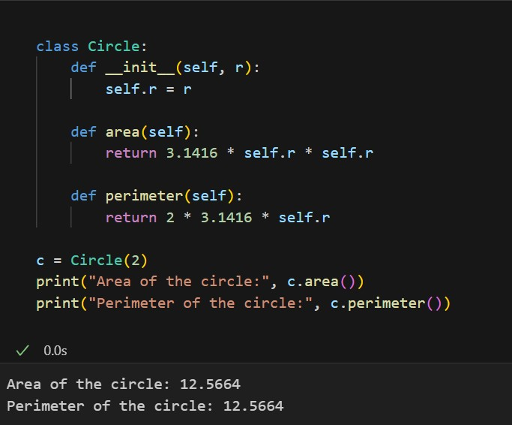

Q : 2 Write a Python class to implement pow(x, n). Do not use built-in math.Pow() function for this code. Also handle this code for all +ve as well as -ve numbers.

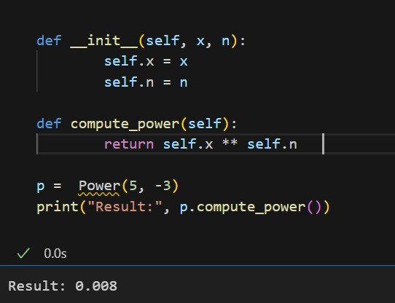

Q : 3 Write a Python code for the following figure:

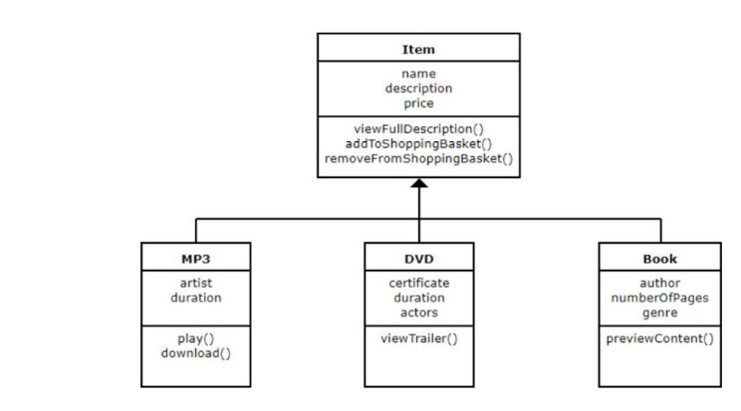

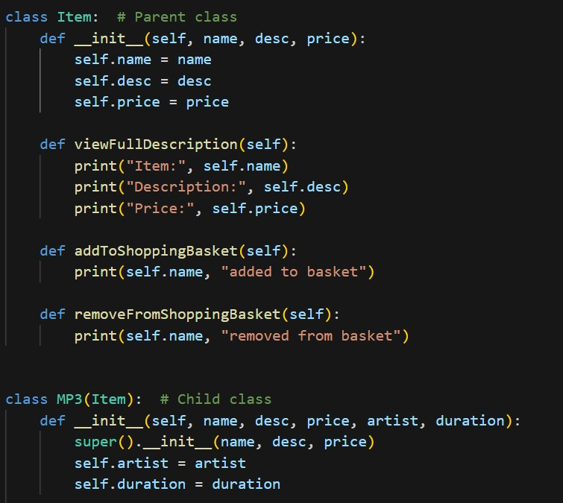

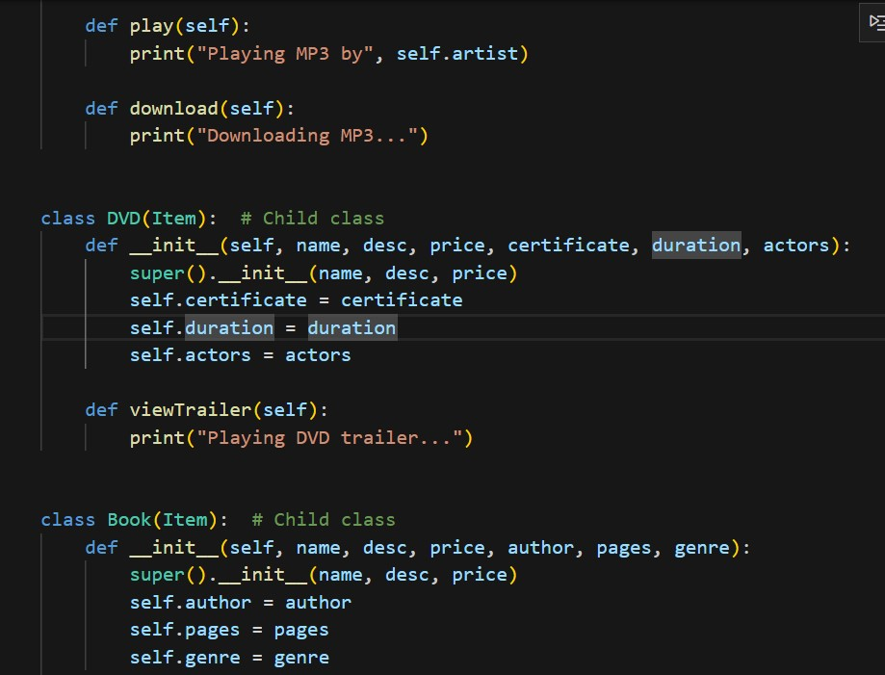

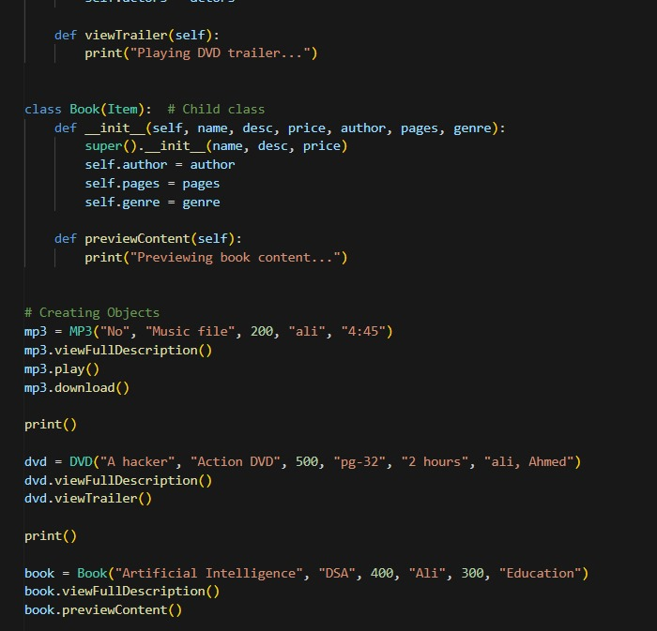

**Output:**

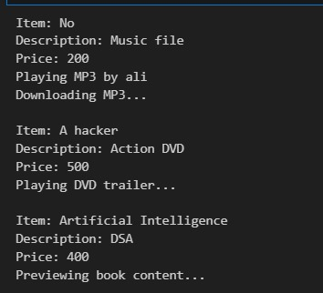

**CONCLUSION:**

This lab helped us understand the basics of Object-Oriented Programming in Python. We learned how to create classes and objects, use constructors, and apply inheritance. By completing the tasks, we practiced building reusable and organized code using OOP concepts.

**-------------------------**